**Common problems in docker cluster and Intellij**

Shuyuan

1. Error: java.lang.SecurityException: sealing violation: can’t seal package…



Cause: the setting you choose to build jar file is wrong. Your current jar file contains Hadoop jar files but actually the Hadoop jar files should be separated from your application jar file.

Solution:

* Remove your current build output and configurations. Delete the 3 folders in the following screenshot if you have them

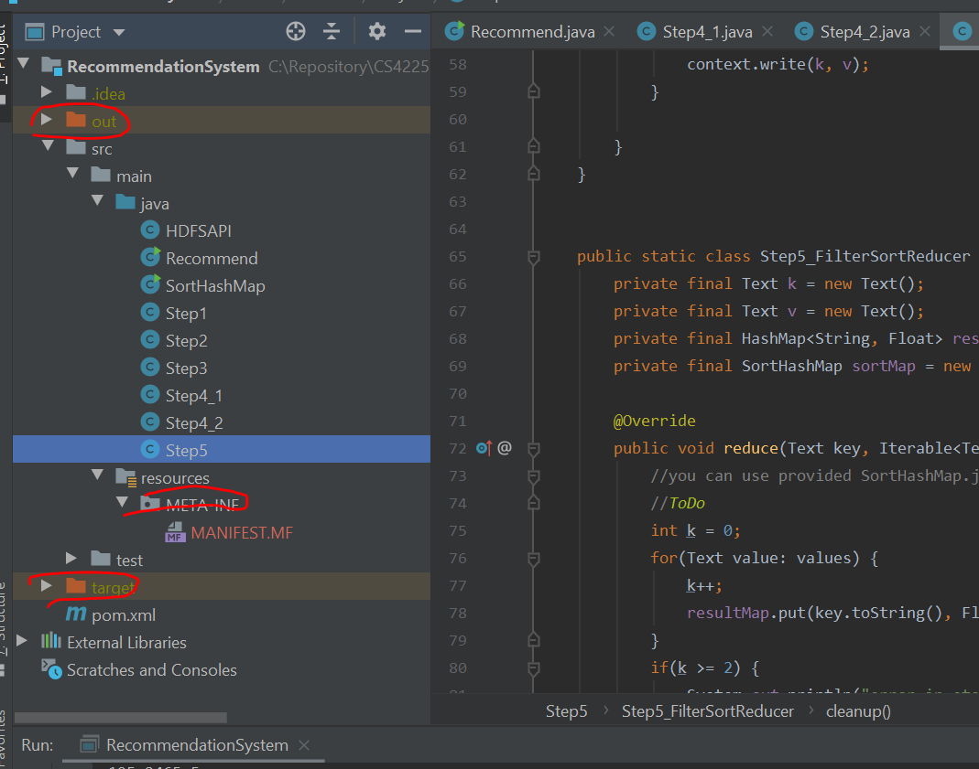

* File -> Project Structure -> delete your current artefact setting

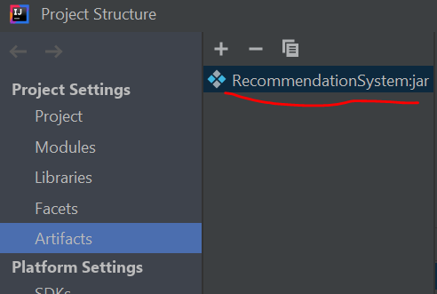

* Click + -> JAR -> From modules with dependencies

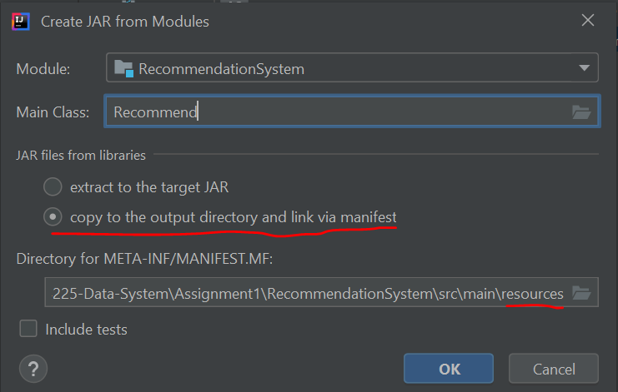

* Then rebuild your code. Now you will find lots of jars in out directory. Copy the 1 jar file for your module into docker.

1. " [fileName] could only be replicated to 0 nodes instead of minReplication (=1)."

Cause: this is a hard problem to solve. This happens because your datanode is not properly started.

Solution:

* Check “hdfs dfsadmin -report”. It may show that your capacity is 0B
* Check “jps”. Your resourcemanager or datanode may not be in the list
* What you can do is:
* “cd /usr/local/hadoop”

“bin/hdfs namenode -format”

“sbin/start-dfs.sh”

“sbin/start-yarn.sh”

(using start-all.sh is not good. This command is deprecated and sometimes cannot start the nodes or resourcemanager properly)

* Check “jps” and “hdfs dfsadmin -report” again
* If the above steps don’t work, you can google. There are some solutions saying that you can delete tmp files. Some people say it works but it doesn’t work on my machine. Another thing you can do is delete the containers and follow the steps to rebuild your cluster. (rebuilding your cluster will actually be faster than googling and trying all the solutions online)

1. Java error: release version 5 not supported in intellij.

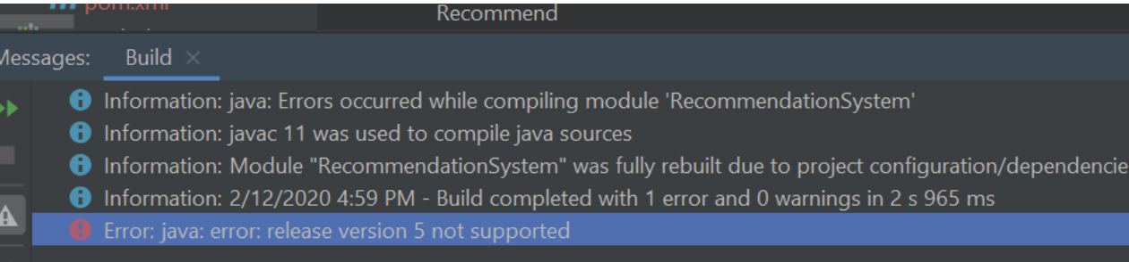

Cause: Your language level and Maven project setting version should be changed so that it can be supported.

When I encounter this error, I am using JDK11.0.5

Solution: I change version to 8

* Add this to pom.xml (your maven project configuration file)

<properties>

<maven.compiler.source>1.8</maven.compiler.source>

<maven.compiler.target>1.8</maven.compiler.target>

<project.build.sourceEncoding>UTF-8</project.build.sourceEncoding>

</properties>

* Change language level to 8

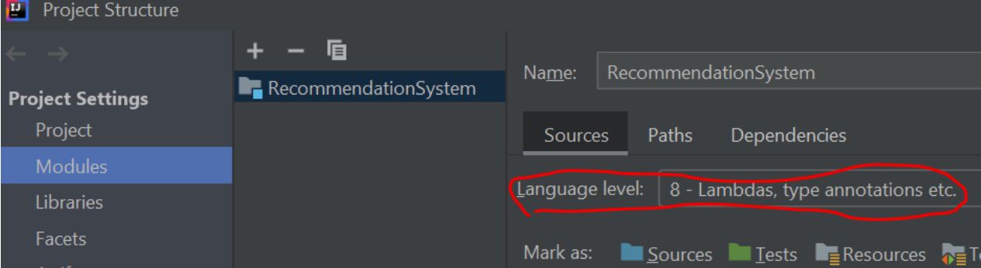

1. has been compiled by a more recent version of the Java Runtime (class file version xxx), this version of the Java Runtime only recognizes class file versions up to xxx

Cause: I was using JDK11.0.5 and when I run jar file in docker cluster, this error came out. This is because your JDK version is too new and Java Runtime cannot support it.

Solution: I change my JDK11.0.5 to JDK1.8 by installing version 8 JDK and change the environment variables for java on my windows machine.

1. Mapreduce job hangs in docker cluster.

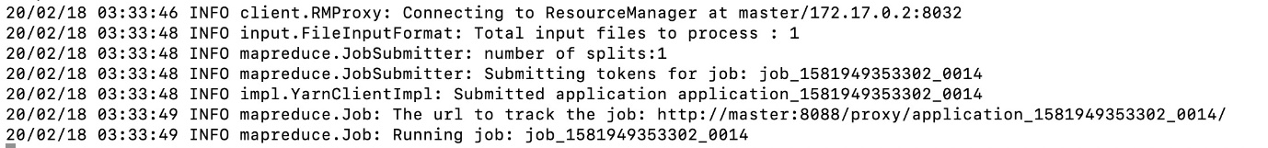

Cause: one possible cause is that you have multiple jobs running and there’s not enough memory for them to run simultaneously.

Solution:

* Check “hadoop job -list”
* If there are other jobs running, kill them “hadoop job -kill <jobid>”

1. When I run my jar in cluster, the mapper gets stuck in the middle.

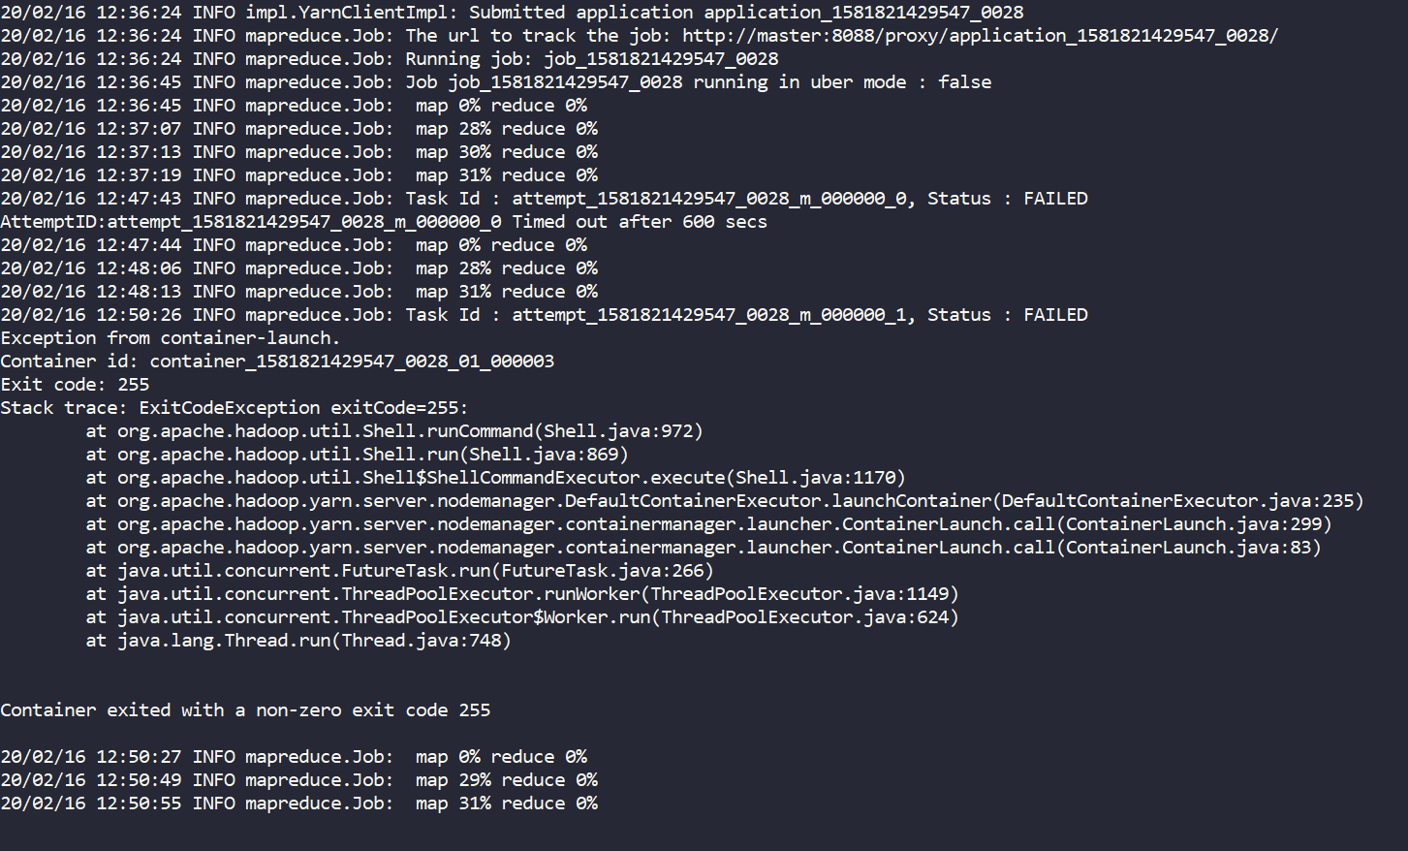

Cause: this happens because there are not enough memory for task 2. For task 1, the file is small and this type of problem doesn’t occur.

Solution: you can try to only take part of the data from data.csv and try it in cluster. And the mapper won’t get stuck here.